**1.Write a simple program to show inheritance in scala.**

**package scala;**

**abstract class Donut(name: String) {**

**def printName: Unit**

**}**

**package scala;**

**class VanillaDonut(name: String) extends Donut(name) {**

**override def printName: Unit = println(name)**

**}**

**object VanillaDonut {**

**def apply(name: String): Donut = {**

**new VanillaDonut(name)**

**}**

**def main(args:Array[String]){**

**val vanillaDonut: Donut = VanillaDonut("Vanilla Donut")**

**vanillaDonut.printName**

**}**

**}**

The screenshots from IntelliJ are as follows:

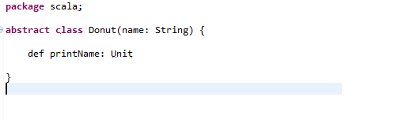

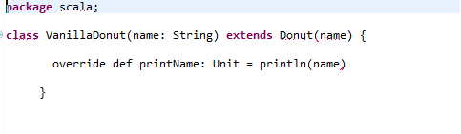

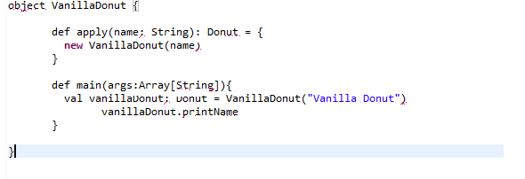

**2.Write a simple program to show multiple inheritance in scala.**

**class A{**

**var salary1 = 10000**

**}**

**class B extends A{**

**var salary2 = 20000**

**}**

**class C extends B{**

**def show(){**

**println("salary1 = "+salary1)**

**println("salary2 = "+salary2)**

**}**

**}**

**object MainObject{**

**def main(args:Array[String]){{**

**var c = new C()**

**c.show()**

**}**

**}**

Output:

salary1 = 10000

salary2 = 20000

The screenshots from IntelliJ are as follows:

